

Project Plan

Version 1.0
February 10, 2006

CPSC 319
Team 7

UBC Botanical Garden and Centre for Plan Research

Dr. Andrew Riseman




Revisions

Version | Primary Author(s) | Description of Version | Date Completed
1.0 | Jack Liu | This is the initial draft of the Project Plan. | Feb 05, 2006
1.1 | Jack Liu, Susannah Poon | Revisions as advised by TA. | Feb 11, 2006

Table of Contents

Revisions i
Table of Contents ii
1. Introduction - 1 -
1.1 Overview - 1 -
1.2 Deliverables - 1 -
1.3 Assumptions and Constraints - 2 -
1.3.1 Constraints - 2 -
1.3.2 Assumptions - 2 -
1.4 References - 2 -
1.5 Definitions, Acronyms, and Abbreviations - 2 -
2. Management Structure - 3 -
2.1 Project Lifecycle - 3 -
2.2 Project Organization - 4 -
2.2.1 External Interfaces - 4 -
2.2.2 Internal Structure - 4 -
2.3 Communication - 6 -
2.4 Risk Management - 6 -
3. Planning and Control - 8 -
3.1 Resource Identification - 8 -
3.1.1 Staff - 8 -
3.1.2 Time - 8 -
3.1.3 Materials - 8 -
3.2 Resource Allocation - 8 -
3.2.1 Milestones - 8 -
3.2.2 Work Breakdown Structure - 9 -
3.3 Tracking and Control - 10 -
3.3.1 Cost - 10 -
3.3.2 Schedule - 10 -
3.3.3 Quality and Functionality - 13 -
4. Supporting Plans - 14 -
4.1 Configuration Management - 14 -
4.2 Quality Assurance - 14 -

1. Introduction

1.1 Overview
This document will outline the plan for the development of “XGene 360”.

XGene 360 is an application that will simulate plant breeding between diploid plants of the same species under similar environment conditions, employing basic concepts and principles of plant breeding and quantitative genetics. The application will be written as a PHP-based web application, which will be accessible by a web browser

The main goal of this is project is to:
- Help students further understand basic concepts and principles in quantitative genetics
- Allow professors to interact with students through problems and feedback
- Allow students to manipulate plant genetics through the process of reproduction
- Provide students with a simulated reproductive environment

1.2 Deliverables
The estimated date of deliverables will be set for the beginning of April, although the exact date will be determined as time passes.

Upon completion of this project, the deliverables will include:
- Necessary application and installation files that will run the actual software system
- The software requirements specification (SRS) document that describes the application from the user’s point of view and provides the contract of agreement between the client and developers.
- An operational manual to instruct users on installing and configuring the application.
- A user manual to instruct users on the functionality available for the application.

Work products such as the project plan and test manual will be considered as internal documentation. Internal work products will not be considered as deliverables.

1.3 Assumptions and Constraints

1.3.1 Constraints
- The project must be completed within 13 weeks.
- E-mail and IM will be the primary forms of communication among the group.
- Communication with the client must be organized; questions must be aggregated and asked only by the communications manager.
- The development of all documents and products will be portioned and distributed among the members of the team. Each individual, after the completion of a milestone, will follow up with a group and/or peer reviewing session focused on the completed section. The individual will notify the team of the need to refine the document or application based on feedback provided by the reviews. The leader of the section will distribute the tasks to the appropriate members of the team.
- All decisions will be rationalized and recorded. The records will be available to all members of the team for referring purposes.

1.3.2 Assumptions
- Research will be reviewed before all meetings.
- Group meetings will take place from 2:00pm to 3:00pm on Tuesdays and Sundays.
- Tasks that will not meet a set deadline will be accommodated. The phase leader for the incomplete tasks will redistribute the work to the most available members of the team.
- Once decisions have been made, no new discussion will arise unless new information is made available.
- In the event of disagreement, the project manager and the phase leaders will make the final decision; if the project manager and the phase leaders cannot reach a decision, the project manager shall make the final decision.

1.4 References
- XGene 360 Software Requirement Specifications Document

1.5 Definitions, Acronyms, and Abbreviations
CVS | A version control system used for record the history of source files, documents, and allows developers to work on the same file concurrently.
IM | Instant messaging – the act of instant communication between two or more people over a network.
PDD | Program Design Document
PHP | Programming language primarily used on the Internet to provide server-side processing.
PP | Project Plan.
RED | Requirement Elicitation Document.
SDD | System Design Document.
SRS | Software Requirements Specification Document.
XGene 360 | The name of the application.

2. Management Structure

2.1 Project Lifecycle
For this project, we will be using the waterfall model; therefore, the major tasks can be broken down into the following phases:

Requirement Analysis
This phase defines the scope, problem, and constraints. This phase will involve active communication with the client in order to gather detailed problem definition. The deliverable for this phase is the software requirement specifications document.

Estimated timeframe: January 16 to February 6.

System Design, Program Design
This phase defines the system architecture, high level and low level design using software development techniques, patterns, and technologies. The deliverable for this phase is the design document which details how the application is implemented.

Estimated timeframe: January 30 to February 20.

Coding
This phase defines the implementation of the program in the chosen language as described in the design document. The deliverable for this phase is the code base of the application.

Estimated timeframe: February 20 to March 20.

Unit & Integration Testing, System testing, Acceptance Testing
This phase determines the correctness of the application. The testing will be performed first on individual components, then a few components as a group, and lastly as complete tests of the system. As the system becomes stable, user and client acceptance testing will be performed. The deliverable for this phase is the application providing the required functionality.

Estimated timeframe: Unit & Integration Testing: March 6 to March 31
System Testing: March 6 to March 31
Acceptance Testing: March 27 to March 31

The schedule listed above is subject to change.

2.2 Project Organization

2.2.1 External Interfaces
The external interfaces for this project will be the following:

Dr. Andrew Riseman – the client
Dr. Riseman is the sole client contact for input during the lifecycle of this project. The communication is done through the communication manager via e-mail unless a group meeting is arranged.

Roman Rudenko – the TA
Roman is a TA and supervisor for this team. The team will be reporting to the TA weekly to provide project status, tasks completion, further tasks, and any problems and concerns. Contact outside of the scheduled meeting will be done through the communication manager via e-mail.

2.2.2 Internal Structure

2.2.2.1 Roles and Responsibilities
Role | Responsibility
Project Manager | Responsible for overseeing the whole project, making executive decisions when needed, and resolving disputes, ensures that workload is distributed fairly.
Communication Manager | Responsible for maintaining the team members’ contact information and for managing the asynchronous communication of the team, as well as for managing team-client communication.
Minutes Manager | Responsible for ensuring that meeting minutes are recording during meetings and posted to the project web site.
Configuration Manager | Responsible for performing forward traceability and reverse traceability.
Progress Manager | Responsible for keeping track of the progress of the project, for keeping the team informed of this progress, and for warning the team when tasks are lagging behind. Also, responsible for gathering the team members’ worked hours each week.
Research and Training Manager | Responsible for managing the investigation and research of aspects related to the project and ensuring the team members are informed of the results of the research.
Risks Manager | Responsible for identifying and bringing to the team’s attention potential risks as well as suggesting action or contingency plans to the team.
Software Versioning Control Manager | Responsible for providing the team with a means to control the various versions of the software and documents.
Web Master | Responsible for designing and managing the team’s web site.

2.2.2.2 Staffing

Managers:

Role | Staff Member | Start Date | End Date
Project Manager | Jack Liu | Jan 4, 2006 | Apr 8, 2006
Communication Manager | Susannah Poon | Jan 4, 2006 | Apr 8, 2006
Minutes Manager | Gabriel Lee | Jan 4, 2006 | Apr 8, 2006
Configuration Manager | Charles Bihis | Jan 4, 2006 | Apr 8, 2006
Progress Manager | Jason Hui | Jan 4, 2006 | Apr 8, 2006
Research and Training Manager | Gabriel Lee | Jan 4, 2006 | Apr 8, 2006
Risks Manager | Charles Bihis | Jan 4, 2006 | Apr 8, 2006
Software Versioning Control Manager | Jack Liu | Jan 4, 2006 | Apr 8, 2006
Web Master | Jimmy Wong | Jan 4, 2006 | Apr 8, 2006

Phase Leaders:

Role | Staff Member | Start Date | End Date
Requirement Analysis | Susannah Poon | Jan 4, 2006 | Apr 8, 2006
System Design | Jason Hui | Jan 4, 2006 | Apr 8, 2006
Program Design | Charles Bihis | Jan 4, 2006 | Apr 8, 2006
Development | Jack Liu | Jan 4, 2006 | Apr 8, 2006
Unit and Integration Testing | Gabriel Lee | Jan 4, 2006 | Apr 8, 2006
System Testing | Jimmy Wong | Jan 4, 2006 | Apr 8, 2006
Acceptance Testing | Jimmy Wong | Jan 4, 2006 | Apr 8, 2006

2.3 Communication
Communication is a crucial key to the success of the project. E-mail and IM will be used on a daily basis to keep everyone’s understanding of the project and its progress up-to-date. Team groupware will be used in order to distribute and share information among members of the team. Verbal communication will be utilized on a weekly basis between group members to provide reports and clarify any issues that may arise.

The communication manager will also disseminate important information regarding newly provided information from the client and the TA.

Meeting schedule:
The current meeting schedule is twice as week: every Tuesday and Sunday from 2:00pm to 3:00pm.

2.4 Risk Management
Risks in the project will be managed by maintaining constant communication among members of the team. Weekly meetings, reports and e-mails will allow the team to identify risks early enough to be compensated for. In general, each risk will be given priority in discussion during a meeting. The risk manager will keep track of all risks that appear and record how each risk will be resolved. Risks will be scaled according to how much impact it will have on the project as a whole and the likelihood of it occurring. High impact, high occurrence risks will be given top priority, while low impact, low occurrence risks will be evaluated as to whether they will be dealt in the near future or not.

The risks identified below are the top five high impact risks with a high likelihood of occurring. Each risk will be given mitigation strategies for avoidance.

Risk | Semantics of any part of the design process is faulty or incompatible.
Type | Technical
Mitigation Strategies | Have frequent meetings in order to reach a consensus and understanding of the overall design.  Clearly define conventions.  Maintain version control.  Maintain frequent developer communication.

Risk | Undesired behaviour of sister application, YellowLeaf, when running with product.
Type | Technical
Mitigation Strategies | Run benchmarks for identification of inconsistencies.  Isolate any inconsistent functions and develop solution.  Study the design of the sister application for preventive knowledge.

Risk | Client is unsatisfied with application interface.
Type | Technical
Mitigation Strategies | Frequently perform usability studies to rectify the design.  Develop alternative interfaces.

Risk | Realization of design takes more time and effort than scheduled.
Type | Managerial
Mitigation Strategies | Schedule development to prioritize the implementation of basic functionality.  Maintain a simple design.  Cut out any features that will not be necessary to implement.

Risk | A developer becomes unavailable or cannot deal with the workload.
Type | Managerial
Mitigation Strategies | Reassign workload so the developer will have a less critical workload.  If the workload is heavy, attempt to distribute it across other developers.  Maintain constant communication in order to detect risk earlier.

3. Planning and Control

3.1 Resource Identification

3.1.1 Staff
There are 6 (six) people working continuously on all phases for this project. No new staff members are expected to be added to the team at any time. Every resource will be involved in the project throughout the entire project.

3.1.2 Time
The application must be fully implemented and installed within 12 weeks. No extension will be possible due to the nature of this project.

3.1.3 Materials
The following software and hardware materials will be used for this project.

3.1.3.1 Hardware
Processor: MAC G4 (dual processor)
Processor Speed: 1GHz
RAM: 1GB

3.1.3.2 Software
Operating System: MAC OS X 10.2.8
Web Server: Apache 1.3.33
PHP: PHP 4.2.3
Database: MySQL 3.23

3.2 Resource Allocation

3.2.1 Milestones
Jan 16 – Jan 23 Initial group meeting, review existing documents
Jan 23 – Jan 30 Begin Requirement Elicitation Document
Jan 30 – Feb 06 Complete first RED draft; Complete Project Plan
Feb 06 - Feb 13 RED and PP Due; begin SDD and PDD
Feb 13 – Feb 20 Complete first SDD draft; begin coding
Feb 20 – Feb 27 Continue on coding; begin testing and debugging
Feb 27 – Mar 06 Continue on coding; begin Unit Testing
Mar 06 – Mar 13 Complete coding; continue testing and debugging;
begin Integration Testing and Overall System Testing
Mar 13 – Mar 20 Complete Testing & Debugging;
Continue on Integration Testing and Overall System Testing
Mar 20 – Mar 27 Complete Integration Testing and Overall System Testing; Final Review of the application by the client
Mar 27 – Mar 31 Complete final coding refinements;
Begin product deployment

3.2.2 Work Breakdown Structure

Tasks:

Documentation: Requirement Elicitation Document
Documentation: System Design Document
Design: Database Structure - Problem
Design: Database Structure – Plants
Design: Database Structure - Accounts
Design: UI
Design: User Privileges
Code: Error Logging
Code: Admin Interface
Code: Professor Interface
Code: TA Interface
Code: Student Interface
Code: Problem
Code: Algorithm – Plant Simulation
Code: Algorithm – Phenotype Expression
Code: Report Generation
Code: Evaluation
Code: User Creating/Modification/Deletion
Code: Problem Creating/Modification/Deletion
Code: Problem Assignment
Code: Password Change
Integration: UI with Code
Test: Functionalities
Test: Security
Test: System Testing
Documentation: Help Documentation
Documentation: Installation Documentation
Code: Installation Script
Test: Installation Script
Deliver: The Application

3.3 Tracking and Control

3.3.1 Cost
This project is under the license provided by the University of British Columbia. The application will be put into the public domain, meaning that customers will be able to use the application free of charge. As a result, there is no allocated budget for this project.

No development tool requiring licensing or distribution fees will be used for the development of this project as the final release is to be open source and is covered by the GPL.

3.3.2 Schedule
The initial project schedule will be recorded with a Gantt chart using Microsoft Project.

The Gantt chart will be used to list the start and finish date of each scheduled task, the owner, and the estimated time to complete the task. Each day is assumed to be 2 (two) hours of working time.

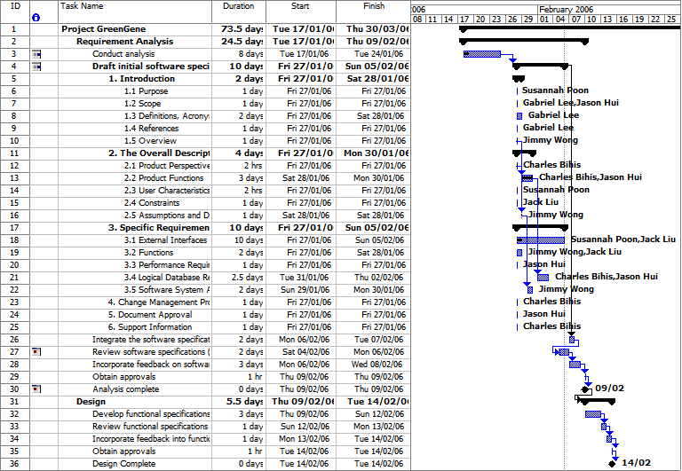
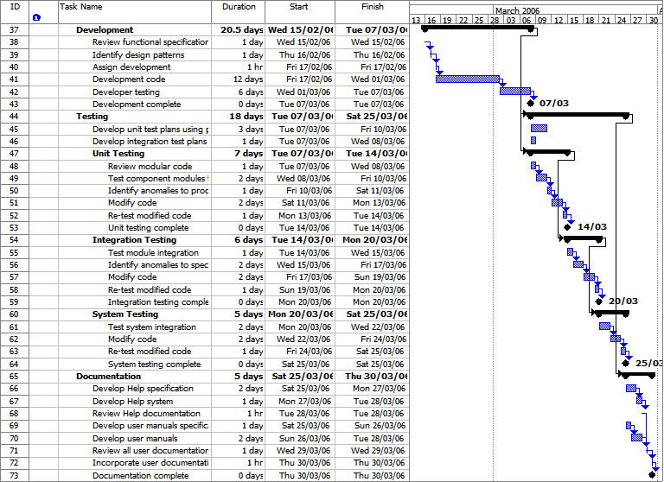

3.3.3 Quality and Functionality
After each phase, the configuration manager is responsible to ensure the application meets the requirement standard outlined in the Software Requirement Specifications document and is implemented to the specification according to the System Design Document.

The quality of code will be maintained by using a software versioning control system as described in Section 4.1 of this document and quality of the application is maintained through the testing as described in 4.2.

Team members will record their individual accomplishments for the week and send the report to the project manager. The project manager will include the reports in the aggregated weekly status report.

Each member will be responsible for tracking the amount of time they spend on various tasks. The progress manager will be responsible for tracking the total amount of time spent on each task. The project manager will be responsible for updating the schedule based on the actual progress.

4. Supporting Plans

4.1 Configuration Management
The team will be using Perforce (Concurrent Versioning System) to manage the project data. Each developer will use a Perforce client to access the file repository.

All files, code, and documents required for the application implementation will be stored on the Perforce server where file versioning and history will be maintained. For a text file, multiple checkouts will be allowed. If a conflict occurs during a submission, the user will be responsible for merging the files to make sure the functionality checked in by the other developer is not lost.

All code that is will be checked into the Perforce server will be tested by the developers to make sure it does not break the build. A build of all files checked into CVS will be performed at least once a week to ensure that the current build is up-to-date and working.

4.2 Quality Assurance
In order to achieve desired functionality, the implementation will be done exactly according to the detailed design documents. Every developer will have their code reviewed by a peer prior to checking in to ensure the implementation is correct and is based on the design document.

All bugs will be logged into a bug database. Each bug will be assigned to the corresponding phase leader, who will then assign it to the appropriate developer for repair. Bugs will be prioritized and will be marked as resolved when it is fixed.

